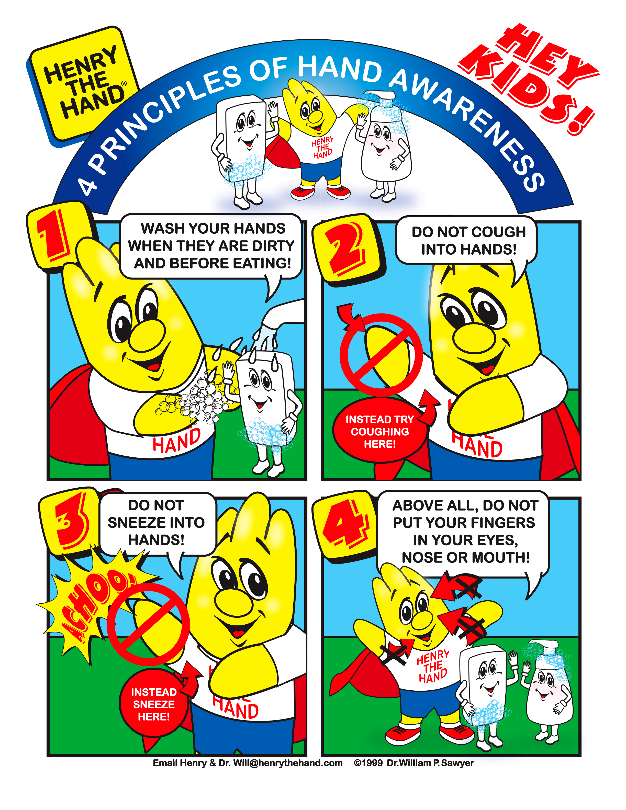
4 principles of hand awareness
Wash your hands wen they are dirty and before eating
Do not cough into hands!
Do not sneeze into hands!
Above all, do not put your fingers in your eyes, nose or mouth!
Instead try coughing here!
Instead sneeze here!
Hey Kids!

